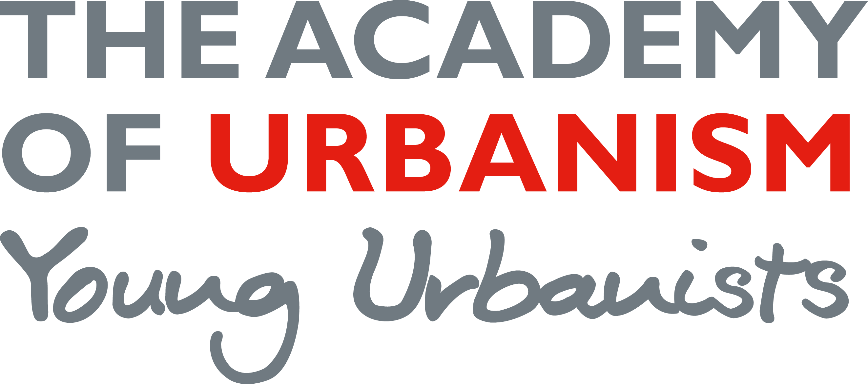

Support for Mentors

Thank you for agreeing to take part in the scheme and volunteering your time and energy in helping one of our Young Urbanists realise their potential.

What is mentoring?

Mentoring is a longstanding form of training, learning and development, providing medium/long term support, guidance and advice. Mentoring is a relationship in which an experienced colleague uses their greater knowledge and understanding of their field to support the development of a more junior colleague.

Mentoring is used as a form of long-term tailored development for the individual. The characteristics of mentoring are that:
- It is a supportive form of development
- It focuses on helping an individual manage their career and improve skills
- Personal issues can be discussed more productively unlike in coaching where the emphasis is on performance at work

For the Young Urbanists Mentoring Scheme, it will involve Academicians supporting students and early stage urbanists in their career and academic development.

Mentoring can be split into three stages: exploration, new understanding, and action planning. The tables below focus on the main strategies and methods required of the mentor.

Exploration
Strategies | Methods
Take the lead | Listen
Pay attention to relationship and develop it | Ask open questions
Clarify the aims and objectives of mentoring | Negotiate an agenda
Support and counsel

New understanding
Strategies | Methods
Support and counsel | Listen and challenge
Give constructive feedback | Ask open and closed questions
Coach and demonstrate skills | Recognise strengths and weaknesses
 | Establish priorities
 | Identify developmental needs
 | Give information and advice
 | Share experience and tell stories

Action planning
Strategies | Methods
Examine options for action and their consequences | Encourage new and creative ways of thinking
Attend to the mentoring process and the relationship | Help to make decisions and solve problems
Negotiate an action plan | Agree action plans
 | Monitor progress and evaluate outcomes

Initial Contact: Getting to know your mentee
(It is the mentee's responsibility to make first contact and to set up initial meetings)

The Young Urbanist Steering Committee will match you with an appropriate mentee, based on the responses to the initial questionnaire. If you are matched with a mentee, we will send you their information in advance, and once we receive confirmation from you, you will be introduced to your Young Urbanist mentee by email.

All mentors and mentees are invited to the Young Urbanists' monthly pub night in London on Monday 2 November 2015 to meet for the first time. (7.00pm, Island Queen pub, 87 Noel Road, Islington, London N1 8HD).

Suggested steps for a successful mentoring relationship:
- If the mentee is unsure or not confident, be understanding and encourage the YU to tell you about themselves. Remember that for some Young Urbanists this will be the first time they have spoken to a person at your level of seniority. Tell them about yourself and talk to them about how you think you can support their goals.
- Agree a set of expectations you would like to see completed within the year. Ensure these are realistic and achievable.

The table below provides you with a number of suggestions to guide your discussions during this first contact with your mentee.

Discussion Topics | Notes
About the Scheme:
- Aims (what does the Young Urbanist hope to achieve?)
- Frequency and method of contact
- Location and duration of meetings
Student-led topics:
- Previous academic experience
- Previous work experience
- Interests
- Career aspirations
- Achievements
Mentor-led topics:
- Education
- Career history
- Typical day
- Skills used
- Current employer
- Career goals
Potential topics for future discussion:
- Job hunting techniques and sources of relevant vacancies
- CVs/covering letters/application forms
- Relevant reading (e.g. industry magazines)
- Professional bodies
- Networking groups/events
- Personal/professional boundaries
- Sector requirements
- Work experience
- Disability & disclosure
- Typical work activities
- Good/bad aspects of profession

We would like mentors to commit to six months of mentoring. We recommend that you meet your mentee in person at least once every six weeks. This amounts to 4 meetings over a six month period. We also expect there to be some email contact over the course of the mentoring period.

Meeting your mentee might take a number of different forms: you could meet at your place of work or theirs, or somewhere neutral. You might invite them to shadow you at work for a day, take them on a site visit, or invite them to sit in on a meeting (if not dealing with confidential matter).

If both you and your mentee wish to continue the relationship, you can continue to meet informally after the end of the mentoring period.

Alexei Schwab (alexeischwab@gmail.com) is the YUSC contact for the mentoring scheme – if you have any problems or concerns about your mentee during the time you are mentoring them, please let Alexei know.

