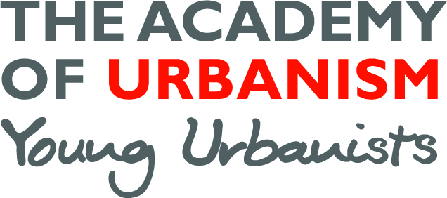

Young Urbanist Mentoring Scheme
Mentor Application Form
Name:
Contact details:
Current role:
Location (city/town):

Background information (approximately 200 words)
Please include some of the following to help us make the best match:

What is your current role, what are you specialisms, what was your route into this position?

I would like to mentor someone who is looking to develop:
Top of Form
Academic work In-job career progression
Bottom of Form
Top of Form
CV development Change of career
Bottom of Form
Top of Form
Portfolio advice Move back into academia
Bottom of Form
Top of Form
First time job hunt Change of job search
Bottom of Form
Top of Form
A bit of inspiration Other
Bottom of Form

I can offer mentoring support in the following areas:
Top of Form
Architecture Transport
Bottom of Form
Top of Form
Planning Urban Policy
Bottom of Form
Top of Form
Urban Design Social Policy
Bottom of Form
Top of Form
Research Regeneration
Bottom of Form
Top of Form
Other
Bottom of Form

Top of Form
I can commit to dedicating a meeting once every 6 weeks (for at least 6 months) and monthly email contact with the mentee (please check to confirm)

Bottom of Form

Top of Form
I can attend the Young Urbanists' London pub night on 2nd November to meet my mentee
Bottom of Form

Top of Form
I would be interested in receiving the Young Urbanist mentor support pack (please check to confirm)

How is it best for the mentee to contact me to set up the first meeting?:

Bottom of Form

