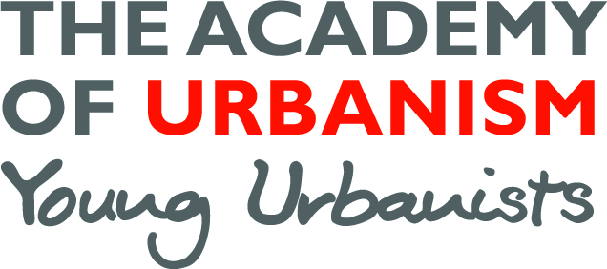

**Young Urbanists Mentoring Scheme**

**Mentee Application Form**

Name:

Undergraduate degree:

Postgraduate degree:

Further qualifications:

Current role:

How should we contact you?:

Location (city/town):

**Background information (approximately 200 words)**   
Please include some of the following to help us make the best match:

*What are you currently doing, what previous work experience have you had, where would you like to be in a year’s time/five year’s time?*

**I am interested in gaining mentoring to support with:**

Top of Form

Academic work In-job career progression



Bottom of Form

Top of Form

CV development Change of career



Bottom of Form

Top of Form

Portfolio advice Move back into academics



Bottom of Form

Top of Form

First time job hunt Change of job search



Bottom of Form

Top of Form

A bit of inspiration Other



Bottom of Form

**I am interested in the following sectors:**

Top of Form

Architecture Transport



Bottom of Form

Top of Form

Planning Urban Policy



Bottom of Form

Top of Form

Urban Design Social Policy



Bottom of Form

Top of Form

Research Regeneration



Bottom of Form

Top of Form

Other



Bottom of Form

We will also use your application to become a Young Urbanist to help inform our matching process.

You should hear from us within 2 weeks.