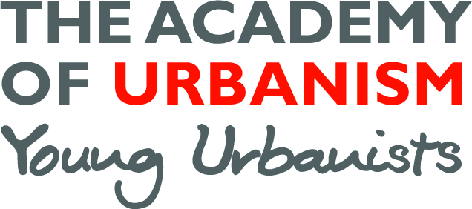
Young Urbanists Mentoring Programme
Name: Click here to enter text.
Undergraduate degree: Click here to enter text.
Post graduate degree: Click here to enter text.
Further qualifications: Click here to enter text.
Current job title: Click here to enter text.
How should we contact you?: Click here to enter text.

Background information (max 200 words)
Please include some of the following to help us make the best match:
What are you currently doing, what previous work experience have you had, where would you like to be in a year’s time?

I am interested in gaining mentoring to support with:
☐ Academic work ☐ In-job career progression
☐ CV development ☐ Change of career
☐ Portfolio advice ☐ Move back into academics
☐ First time job hunt ☐ New job search (not first position)
☐ A bit of inspiration ☐ Other
I am interested in the following sectors:
☐ Architecture ☐ Transport
☐ Planning ☐ Urban Policy
☐ Urban Design ☐ Social Policy
☐ Research ☐ Regeneration
☐ Other

We will also use your application to become a Young Urbanist to help inform our matching process.
You should hear from us within 1 month.

