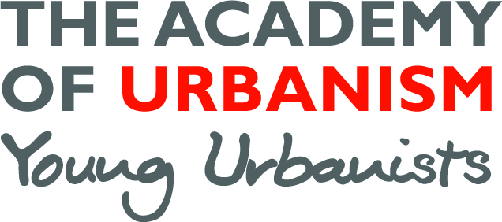
Young Urbanist Mentoring Programme – For mentors
Name: Click here to enter text.
Contact details: Click here to enter text.
Current role: Click here to enter text.

Background information (max 200 words)
Please include some of the following to help us make the best match:
What is your current role, what are you specialisms, what was your route into this position?

I would like to mentor someone who is looking to develop:
☐ Academic work ☐ In-job career progression
☐ CV development ☐ Change of career
☐ Portfolio advice ☐ Move back into academia
☐ First time job hunt ☐ New job search (not first position)
☐ A bit of inspiration ☐ Other

I can offer mentoring support in the following areas:
☐ Architecture ☐ Transport
☐ Planning ☐ Urban Policy
☐ Urban Design ☐ Social Policy
☐ Research ☐ Regeneration
☐ Other
☐ I can commit to dedicating a meeting once every 3 months (for at least 1 year) and monthly email contact with the mentee (please check to confirm)

How is it best for the mentee to contact me to set up the first meeting?: Click here to enter text.

☐ I would be interested in receiving the Young Urbanist mentor support pack (please check to confirm)

